**Assignment No. 02**

***Course title:*** *Object Oriented Analysis and Design*

***Course code:*** *CSE-314*

*3rd Year 1st Semester Examination 2023*

**Date of Submission**: 09-Sep-2024



**Submitted to-**

[**Dr. Md. Musfique Anwar B.Sc (JU), MSc. (Japan), PhD (Australia)**](https://juniv.edu/teachers/musfique.anwar)

*Professor*

*Department of Computer Science and Engineering*

*Jahangirnagar University*

*Savar, Dhaka-1342*

[***Sarnali Basak, BSc(JU), MSc (The University of Edinburgh, UK)***](https://juniv.edu/teachers/sarnali.cse)

*Associate Professor*

*Department of Computer Science and Engineering*

*Jahangirnagar University*

*Savar, Dhaka-1342*

|  |  |  |  |
| --- | --- | --- | --- |
| **Sl** | Class Roll | Exam Roll | Name |
| 01 | 383 | 210903 | Abdullah Nazmus-Sakib |

**1. Key parts of the sequence diagram:**

1. **Teacher Actions**:

• Logs in, selects a class, marks attendance, and submits it.

2. **Student Actions**:

• Logs in and checks attendance records.

3. **Principal Actions**:

• Reassigns teachers, when necessary, approves requests for archived attendance.

4. **Guardian Actions**:

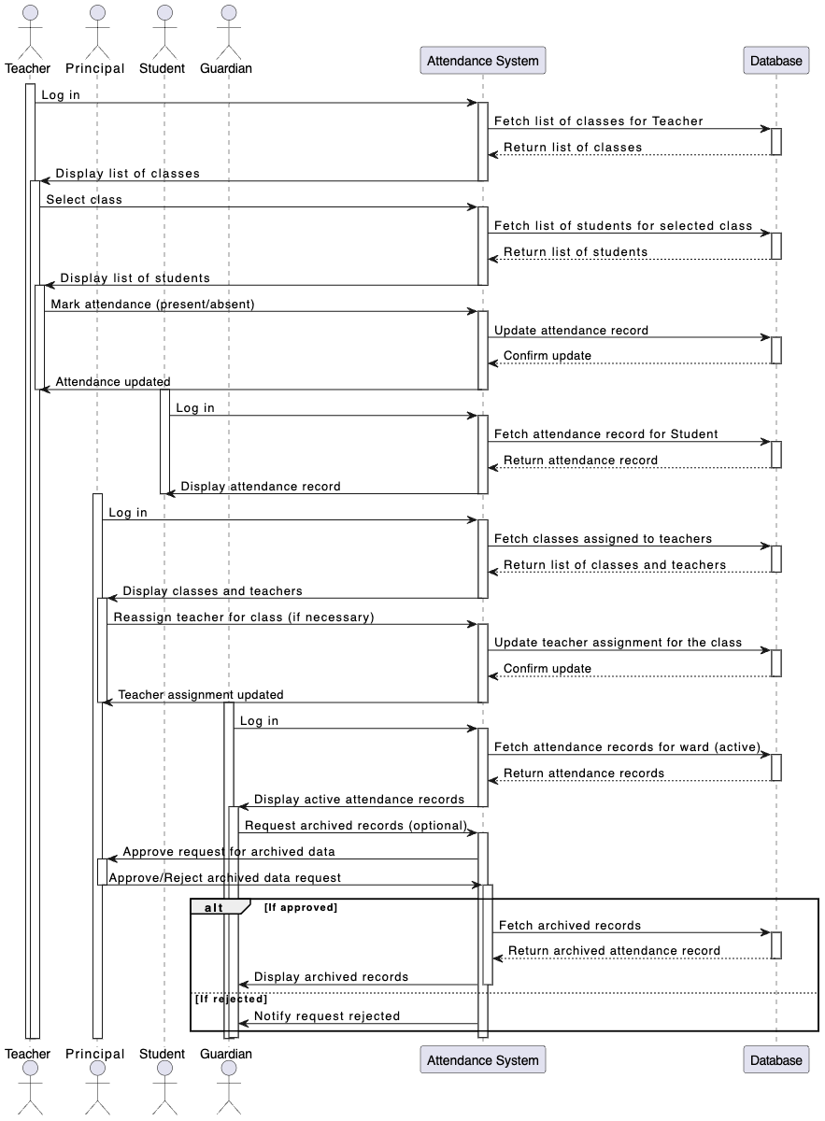 • Views active attendance and requests archived attendance data.

**2. Key parts of the sequence diagram:**

1. **Instructor Actions**:

• Notifies students about the exam date and material.

• Prepares the exam paper and sample solutions.

• Ensures the exam is copied and distributed to students on the designated date.

2. **Student Actions**:

• Receives the exam notification.

• Writes answers during the exam and submits their papers.

3. **Teaching Assistant (TA) Actions**:

• Receives the exam papers and sample solutions from the instructor.

• Marks the exams and returns them to the instructor.

4. **Marking and Returning**:

• The instructor records the marks and returns the graded papers to the students.

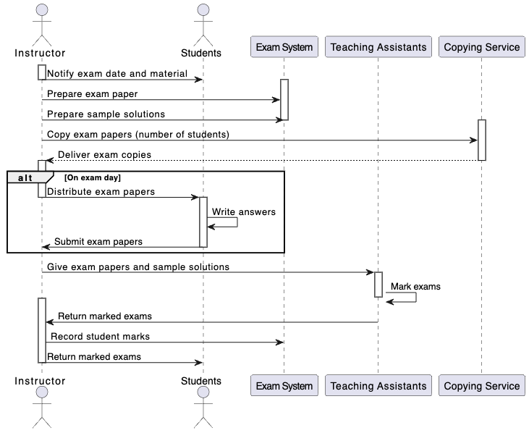

**3. Key parts of the sequence diagram:**

1. **Student logs in** to the Course Management System (CMS) to enroll in a course.

2. **CMS checks** the student’s profile to ensure they meet course eligibility requirements (e.g., previous course completions).

3. **If eligible**, the student selects up to 5 units for the semester, and the system checks for pre-requisites and co-requisites.

4. If all conditions are met, the student is **enrolled in the selected units**, and the total fee is calculated.

5. The student **pays the full fee up-front**, and the payment is confirmed.

6. If any pre-requisite or co-requisite conditions are not met, the enrollment fails, and the system notifies the student.

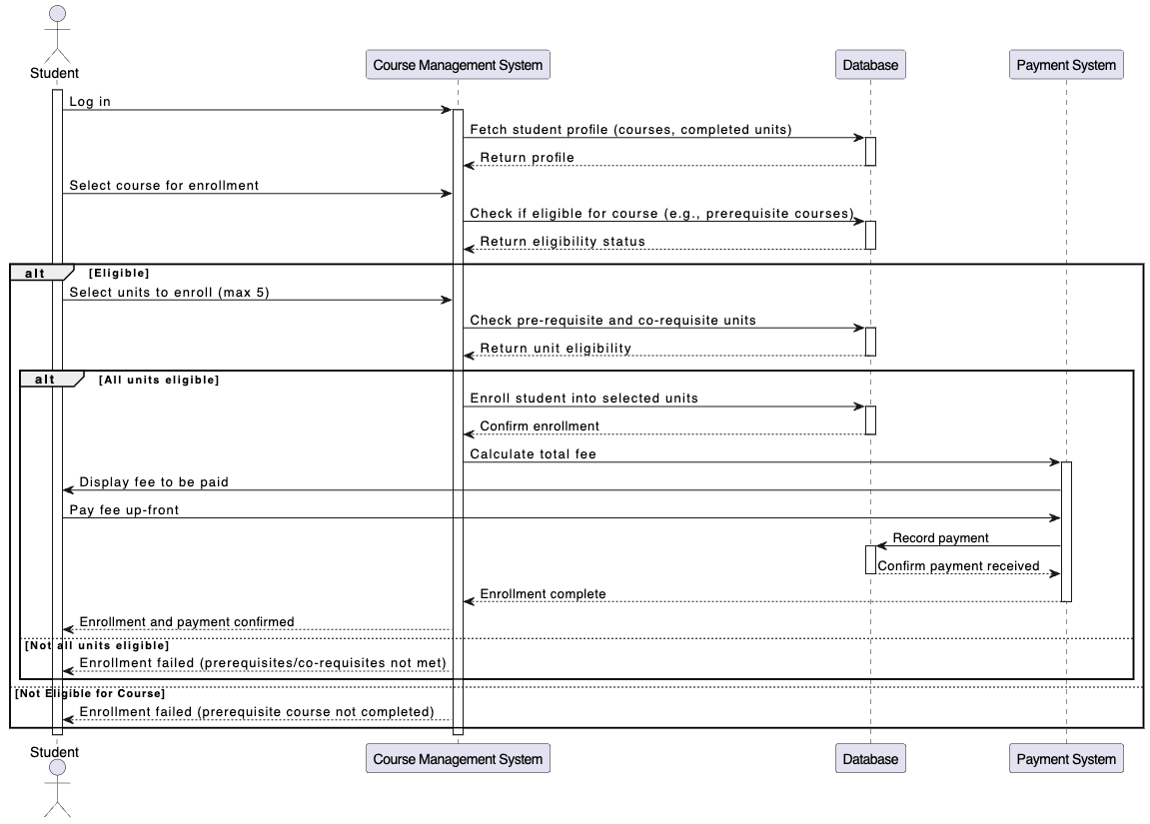

**4. Key parts of the sequence diagram:**

1. **Customer Actions**:

• Browses and adds items to the shopping cart, and optionally removes items.

• Proceeds to checkout, reviews the order, selects a payment method, and makes a payment.

2. **Payment Process**:

• The payment gateway confirms the payment, and the system records the payment in the database.

3. **Sales Employee Actions**:

• Receives the order and purchase confirmation.

• Sends the electronic order to the warehouse.

4. **Warehouse Actions**:

• The warehouse employee updates the order status in the system.

5. **Customer Checks Order Status**:

• The customer can check the order status at any time, and the system retrieves the latest status from the database.

